
DEWATERING SCREENS—Operation and Performance

McLanahan Dewatering Screens have the highest
capacities available in the industry and can process up
to 400 tph of coarse sand on a single machine.
(800) 792-7427
HOW DEWATERING SCREENS WORK
Removal of ‘free’ water is easy, but high acceleration (typically 5g) is needed for capillary water. This is most effective with relatively low frequency, high amplitude motion. McLanahan Dewatering Screens operate at -10mm amplitude.
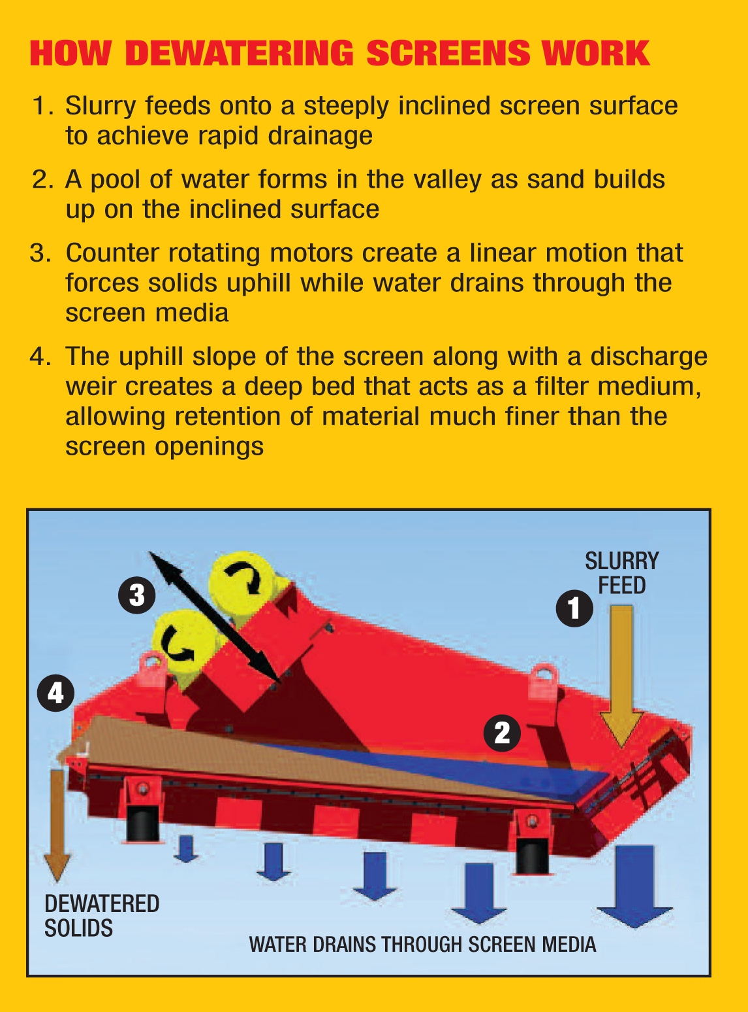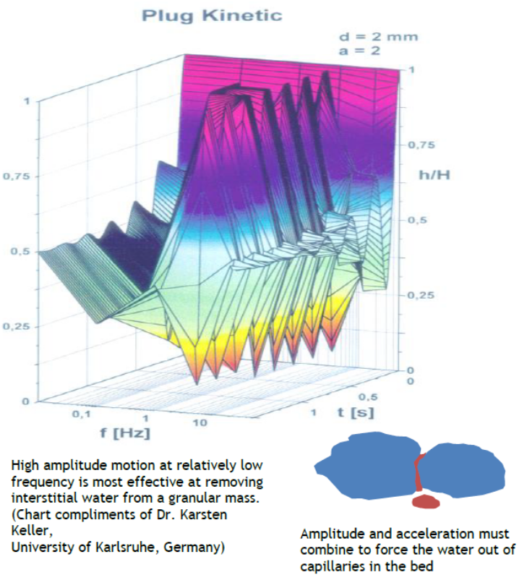
MCLANAHAN DEWATERING SCREENS PROVIDE A DRIER, DRIP-FREE PRODUCT THAT
OTHER TYPES OF EQUIPMENT CANNOT PROVIDE.

DEWATERING • DESLIMING • DEGRITTING • RINSING • SCRUBBING • WASHING

From primary sand products to ultra fines recovery, the resulting
improvements in housekeeping and immediate availability
of products mean bottom line benefits for your company!

Get The McLanahan Advantage
Contact Your McLanahan Dealer Today:
www.GulfAtlanticEquipment.com
Info@GulfAtlanticEquipment.com

